# Prepared by: Dr. Hitesh Kumar Sharma

**Lab Exercise 2– Terraform AWS Provider and**

**IAM User Setting**

**Prerequisites: Terraform Installed: Make sure you have Terraform installed on your machine. Follow the official installation guide if needed.**

AWS Credentials: Ensure you have AWS credentials (Access Key ID and Secret Access Key) configured. You can set them up using the AWS CLI or by setting environment variables.

**Exercise Steps:**

**Step 1: Create a New Directory:**

Create a new directory for your Terraform configuration:

**mkdir aws-terraform-demo cd aws-terraform-demo**

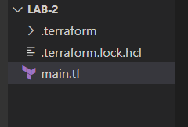

**Step 2: Create Terraform Configuration File (main.tf):**

Create a file named main.tf with the following content:

**terraform { required_providers {**

**aws = { source = "hashicorp/aws" version = "5.31.0"**

**}**

**}**

**}**

# Prepared by: Dr. Hitesh Kumar Sharma

**provider "aws" { region = "ap-south-1" access_key = "your IAM access key" secret_key = "your secret access key"**

**}**

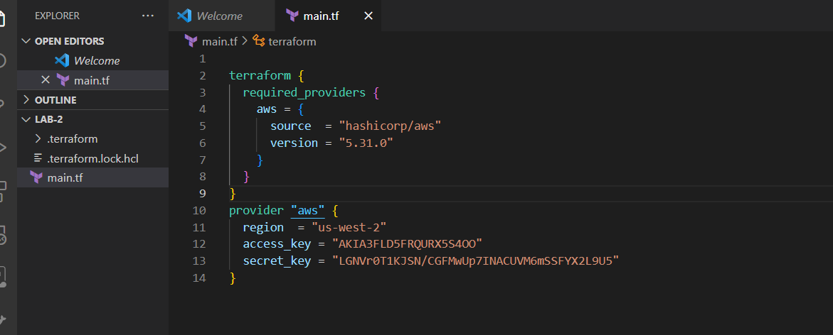

This script defines an AWS provider and provisions an EC2 instance.

**Step 3: Initialize Terraform:**

Run the following command to initialize your Terraform working directory:

**terraform init**

